

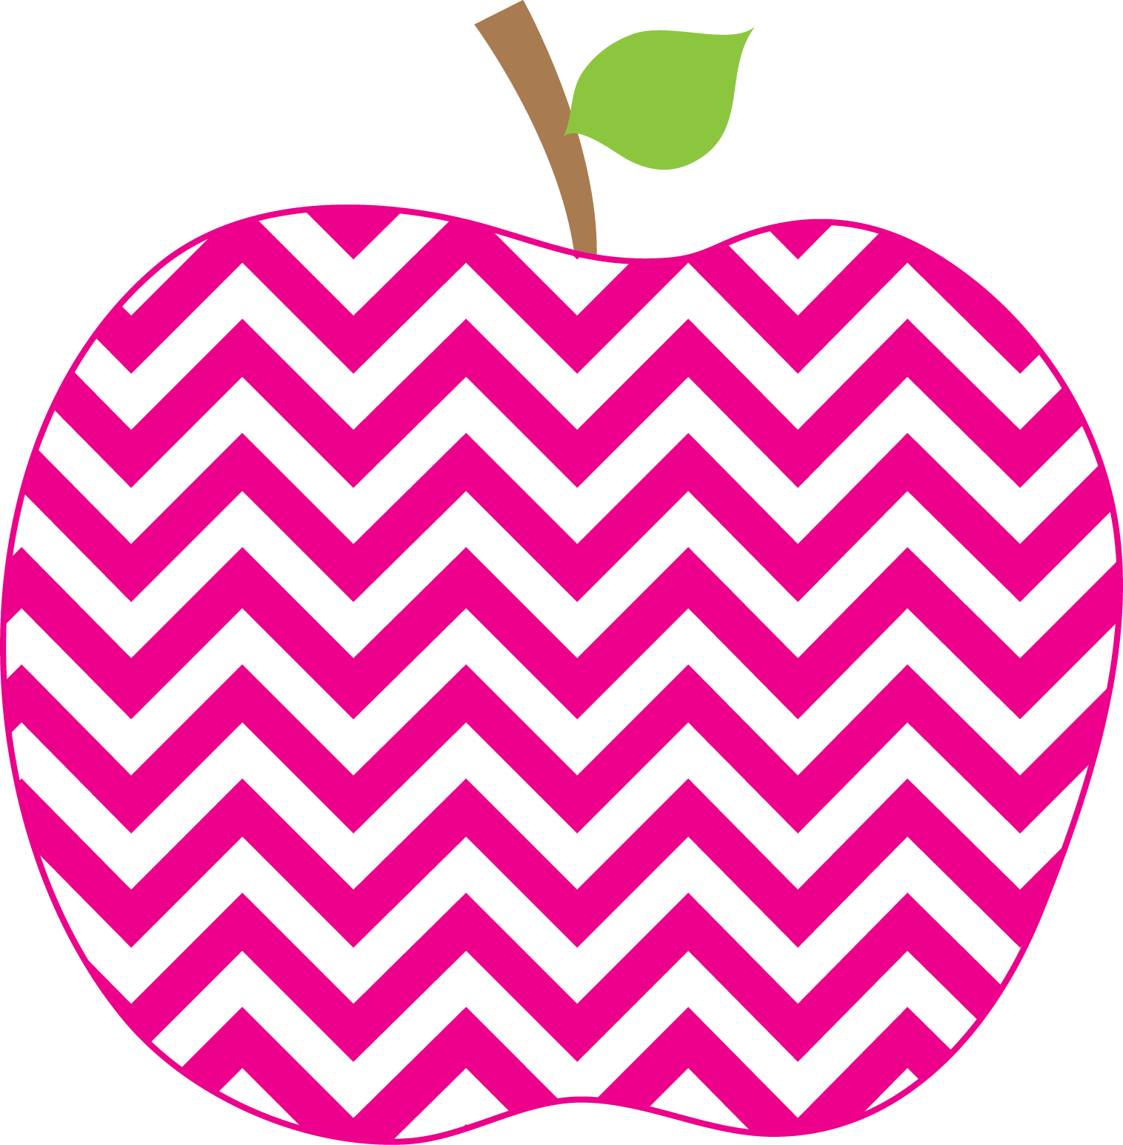



Austria’s Class News
Ms.
November 25, 2024

Phonics- This week we have been focusing on reading and writing words that have digraphs and consonant blends using different strategies we have learned (tapping the words with our fingers, chopping the words, sliding through the words). We have been practicing making these words with our magnetic boards in small groups as well.
Reading- We are learning how to be word detectives and how to pay attention to the middle of words. We have also been making sure our voice matches what we are reading- If we are happy we are adding happy emotion to our reading, If we are mad we add mad emotion, etc. We continue to work in our small groups and are work on various skills in our groups.
Writing- This week we have started How To Writing. We are writing about how to do certain activities. Together this week we wrote about how to come to the rug for a lesson. We are incorporating our transition words into our writing (First, Next, Then, and Last). Together we wrote First, we stand up at our seats. Next, we push our chairs in. Then, we walk over to the rug, we do not run to the rug. Last, we sit criss cross applesauce on the rug. Each student made their own list of what they know how to do for future writing pieces.
Math- We are learning how to add double digit numbers this week. We are also learning about place value of our two-digit numbers. We are using place value blocks to represent our numbers and help us add (54 +24=?) (the number 54 has five tens and 4 ones the number 24 has two tens and 4 ones, when we put these numbers together using our manipulatives, we can see that the answer is 78 because we used 7 tens and 8 ones to make our new number). We are reviewing skip counting by 10s as well when we count our manipulatives to get the answer.
Social Studies- This week we began a new unit on Communities. We are learning about different types of communities (Rural, Urban and Suburban). We are also learning what a home is and different types of homes that people may have.

This Week’s Focus
Celebrations
Happy Thanksgiving!!

December 12th field trip to see the Nutcracker at the Bardavon.
Reminders
Upcoming Events

